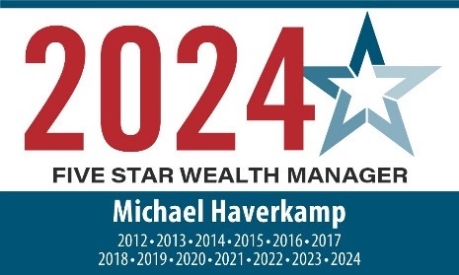

  - Five Star Wealth ManagerSM Award Winner
  - THIRTEEN YEARS IN A ROW
Michael Haverkamp, CFP® of Bridge & Branch Wealth Partners is proud to once again be recognized as a Five Star Wealth Manager, for the thirteenth year in a row.
This distinction is only awarded to wealth management professionals who show a commitment to clients, demonstrate strong industry credentials, and are evaluated on the quality of their current practice.
Mike began his career in banking, but his drive and passion to further understand clients’ needs provided the perfect foundation for his work as a financial advisor.
Seeking to provide professional guidance along with personalized and tailored service are the trademarks of Mike’s business. He believes advisors should be sincere, and trustworthy and always work in the best interest of the client. From web-based information to in-depth reviews, financial planning, and his support staff, Mike is determined to assist clients in developing strategies to pursue their financial goals.
Clients turn to Mike to define long-term investment objectives and build a personalized investment portfolio. As a full-service financial services firm, Bridge & Branch Wealth Partners offers clients access to an assortment of quality, non-proprietary products and services, including:
- Financial Planning
- Retirement Planning
- Investment Portfolio Analysis
- Fee-based Asset Management
- Education Planning
- Variable and Fixed Annuities
- Corporate 401(k), Retirement Plan & Investment Management
- Tax Planning
- Life and Long Term Care Insurance
Bridge & Branch Wealth Partners serves individuals, families, corporate executives, and business owners throughout the country with a focus on the Twin Cities, Greater Minnesota, and Western Wisconsin. Our team of investment professionals works together to create a personalized investment portfolio designed specifically for each client’s needs. We provide tailored investment strategies that are aligned with your risk tolerance to pursue your financial goals.

2024 Five Star Wealth Manager Program: A Distinguished Award
The Five Star Wealth Manager award, administered by Crescendo Business Services, LLC (dba Five Star Professional), is based on 10 objective criteria. Eligibility criteria – required:
- Credentialed as a registered investment adviser or a registered investment adviser representative;
- Actively licensed as a registered investment adviser or as a principal of a registered investment adviser firm for a minimum of 5 years;
- Favorable regulatory and complaint history review (As defined by Five Star Professional, the wealth manager has not;
  - Been subject to a regulatory action that resulted in a license being suspended or revoked, or payment of a fine;
  - Had more than a total of three settled or pending complaints filed against them and/or a total of five settled, pending, dismissed or denied complaints with any regulatory authority or Five Star Professional’s consumer complaint process. Unfavorable feedback may have been discovered through a check of complaints registered with a regulatory authority or complaints registered through Five Star Professional’s consumer complaint process; feedback may not be representative of any one client’s experience;
  - Individually contributed to a financial settlement of a customer complaint;
  - Filed for personal bankruptcy within the past 11 years;
  - Been terminated from a financial services firm within the past 11 years;
  - Been convicted of a felony
4. Fulfilled their firm review based on internal standards;
5. Accepting new clients. Evaluation criteria – considered:
6. One-year client retention rate;
7. Five-year client retention rate;
8. Non-institutional discretionary and/or non-discretionary client assets administered;
9. Number of client households served;
10. Education and professional designations. Wealth managers do not pay a fee to be considered or placed on the final list of Five Star Wealth Managers. The award does not evaluate the quality of services provided to clients. Once awarded, wealth managers may purchase additional profile ad space or promotional products. The Five Star award is not indicative of the wealth manager’s future performance. Wealth managers may or may not use discretion in their practice and therefore may not manage their client’s assets. For more information, visit fivestarprofessional.com.

1060 Dakota Drive Suite 204, Saint Paul, MN 55120 | Direct 651.643.8402 | Fax 651.634.6346
bridgeandbranchwealthpartners.com
Securities and Advisory services offered through LPL Financial, a registered investment advisor. Member FINRA & SIPC.

